Medi-Station app
WASEEM Dollie – 216040566
Zaeem petersen– 219010145
ilyaas davids - 219466424
DANIELLA BURGESS – 219446482
THABISO MATSABA – 220296006
SIPHOSETHU FENI - 217237614
FORMAL REPORT PROJECT 3 Group 10
2022
Table of Contents
INTRODUCTION 1
ERD 2
SYSTEM DOCUMENTATION 3
Future aspect 3
The app architecture 3
Mapping topics on the app 4
Icon 4
Splash screen 4
Login and Register screen 4
Doctor screen 5
Appointment screen 5
Contact Page 5
USER DOCUMENTATION 6
Prerequisites 6
What the user will be able to do with our application 6
The Database 7
The Contact Page 9
CONCLUSION 10

INTRODUCTION

Our group started working on an android doctor system at the beginning of the year. This application was made with the intention of being used more frequently by sick people or patients who want to ask a doctor about a condition. Because it's so simple to use regardless of age, this software appeals to both younger and older generations.
To the best of our ability as students using the knowledge we have acquired at university, the group designed and created this application. This is a first step towards bigger things, and ideally someday we'll have our own expert app.

ERD

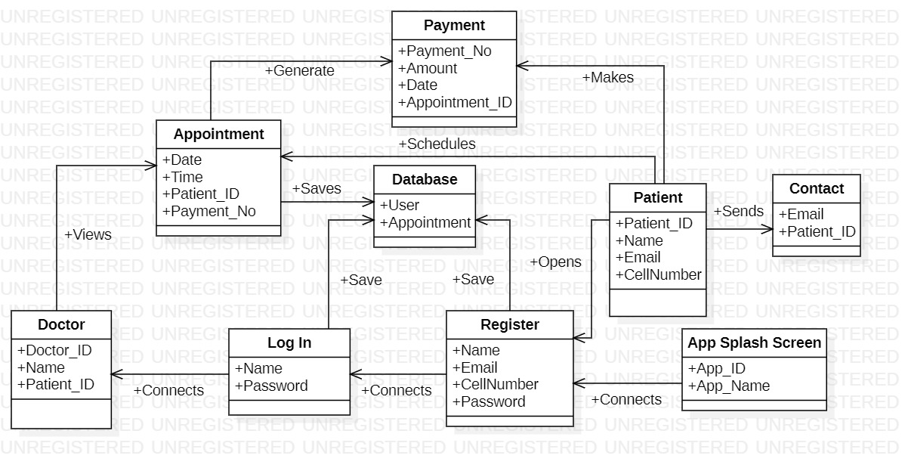
Above is the updated ERD that our project is based on.

SYSTEM DOCUMENTATION

Future aspect
We are entering into a new era where mobile applications are taking over. Businesses are benefitting from this ease of use and on-demand resources. This new phase makes everything easier and more accessible for patients to help them book an appointment if they need assistance.
This application that the group designed is to link patients up with doctors if they feel sick or need assistance with something medically. People get sick every day and often have to sit in a long line when seeking medical advice at the doctor’s office. This app makes it easy to book and is relatively easy to navigate, and it is designed to not make the patient confused as there are limited buttons which cuts straight to the point.

The app architecture
This app consists of three layers:
- The presentation layer – the overall look of the application
- The business layer – the functions of the app
- The data layer – stored information on the database

Although the primary focus of the app is what the app can do for the patient which the doctor booking system, the presentation layer is as important as it makes the app presentable to the patient. The look makes the patient enjoy using the app more. The colours that were used were red and black as this gives the layout a calm but sophisticated look. The font that was used wasn’t too distracting as it also gives the app a sense of professionalism.
The business layer provides the workflow of the app, and this is where most of the time will be spent on the app is selecting a doctor and booking an appointment. This layer is the core of the app as this was the focus when trying to build this app.
Every app needs a database where information is stored and kept. In the case of this app, the data layer is comprised of a Firebase database which we as a it was easier to create as this is used for login and register and keeps track of patient information.
As well as, it keeps records of appointments made by the user so the user can see their appointments made in their account by the doctor’s name.

Mapping topics on the app

Icon
The very first thing you see when looking at this app is the icon picture when a patient is about to open the application. This is very important as a user gets a first impression of what he/she thinks the app is going to look like. As for our icon we have chosen one that looks professional yet elegant that displays the colours of the icon in the app. Making it look like a medical application.

Splash screen
All professional apps have splash screens. Let’s look at the most successful social media handles such as Instagram, Facebook, and Twitter. When opening these apps, a screen pops up that last for 2-3 seconds. From here it takes you to the main page of the app. Our Medi-Station application has a splash screen too which makes it look more professional. The splash screen takes the patient to the login page.

Login and Register screen
The system is designed to capture users/patients’ information within a database to keep track of their profile and save what they do on it. If one or more fields are left out the system will display a popup message saying that the field is empty and that it should be filled out before moving onto the next part of the app. If these details are not filled in the user will not be able to use the app. There are also error messages that prevent the users from entering an invalid email, passwords must be more than 5 characters long and the cell number cannot be more than or less than 10 digits.

Doctor screen
This is a page after the login screen which shows the patient the list of doctors available which the patient will be able to choose a doctor and from there onwards using the appointment button go to the appointment page to book.

Appointment screen
This is where the patient can book an appointment by selecting a date and a timeslot to be consulted in. The app only allows users to book in advance (Changeable between a day after or a week after the current date) and not on the day. This is to prevent the doctors from the last-minute appointments being made has they only have certain time slots available. If the same time and date is being booked an error message will come up saying that the date and time has been reserved already thus not allowing duplicates of the date and time. This time and date will be saved to a database where the doctor can view the patient’s id and the information selected. The patient’s phone number is used as their unique key and the primary key is used as the patient’s id. The patient is allowed to view their own ordered by their id and the earliest date listed in the appointment made tab. The user can cancel any appointment at any time.

Contact Page
This is where the patient can send an email to Medi-Station if there is any query they would like handled. The emulator is connected to Gmail where a direct email can be sent.

USER DOCUMENTATION

Prerequisites
When the patient enters the app, they will be greeted by a splash screen. The splash screen displays the Medi-Station name as well as the logo. The patient will then have to create an account on the registration page and after the patient fills in the necessary details, they will then be proceeded to the login page where they can enter the app. Their information will be stored in the firebase database where the doctor can view the information. Patients need to register with full name, email, cell number and create a password. Patients will then have to login with their name and password.
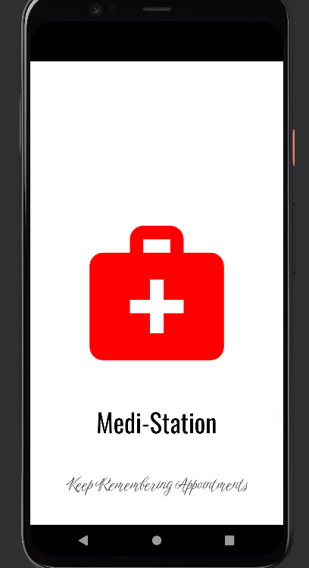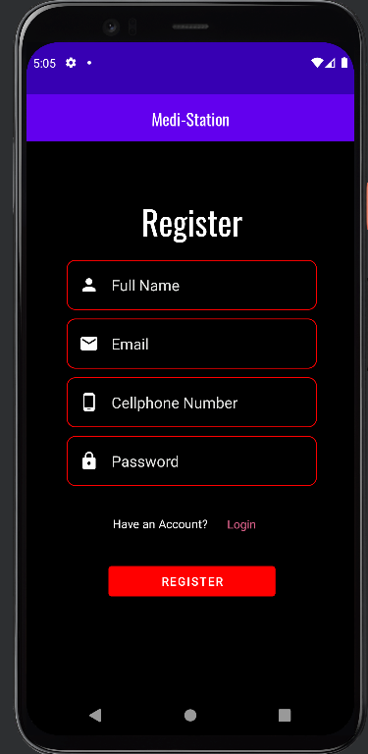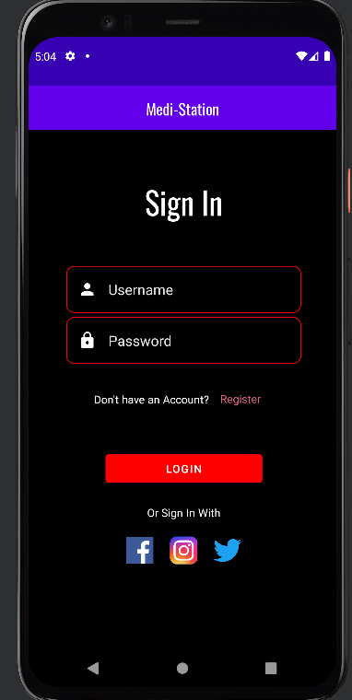
Splash Screen Register Screen Login Screen

What the user will be able to do with our application
The main objective of our application is to allow the patient to view the doctors and book an appointment if they need any medical advice. They will also be able to use the integrated email contact page which allows users to send an email from the application. On the doctors screen there is a back button that takes the patient back to the login page. Patients can choose a doctor and click on the appointment button next to the doctor they would like to see. This will take them to the appointments screen where they can book as well as see what appointments they have booked. Ontop is a back button that takes patients back to the doctors page and a next button that takes patients to the contact page.
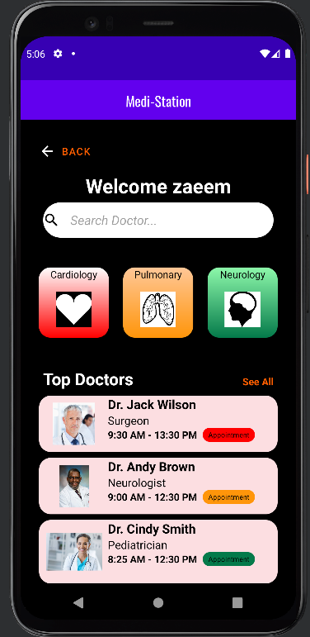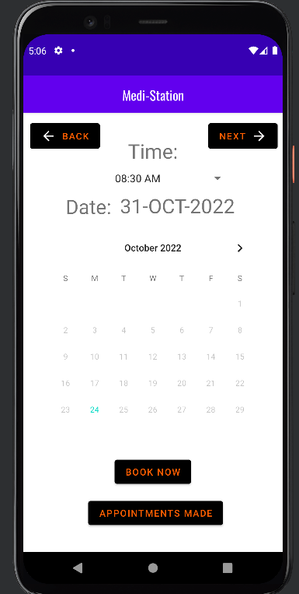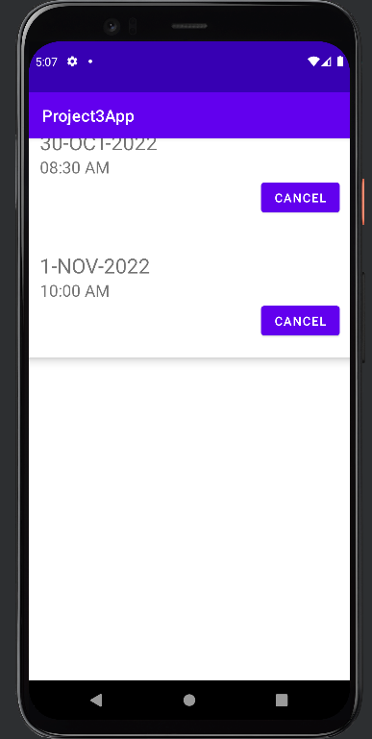
Doctor Screen Appointment Screen Appointments made

The Database
We have used a Firebase database to store our data from the patients. We chose this database due to the fact that it was integrated into android studio, which is the IDE that we are using. The patients can register on the register page of the app, they can then log in using the correct credentials, if their entered username and password is equal to a username and password that is stored in the database then they will be logged in. The database will also store appointment dates. Register/login information as well as appointments made can be viewed by the doctor in Realtime database.
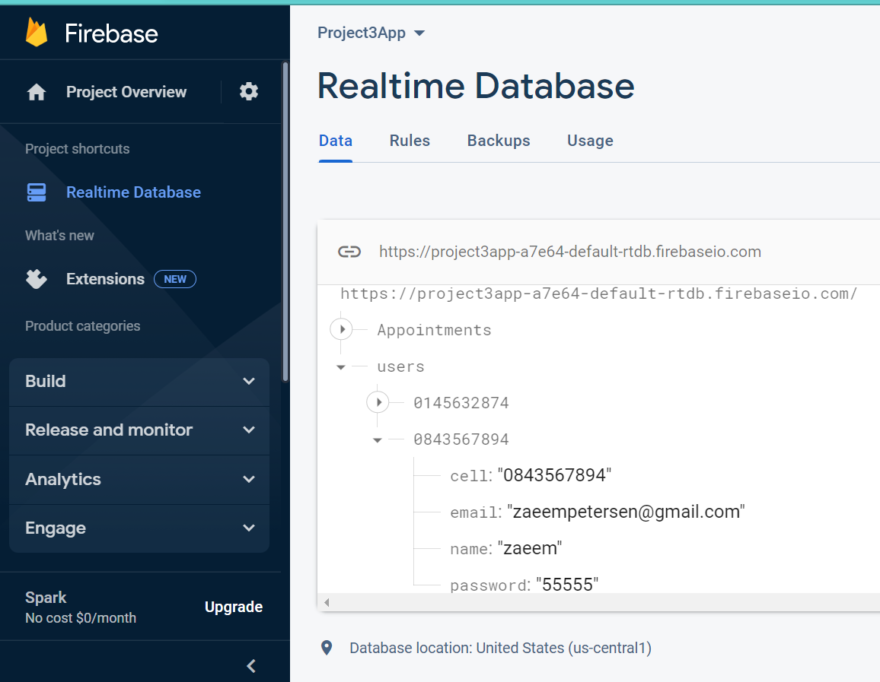
Patients register/login information
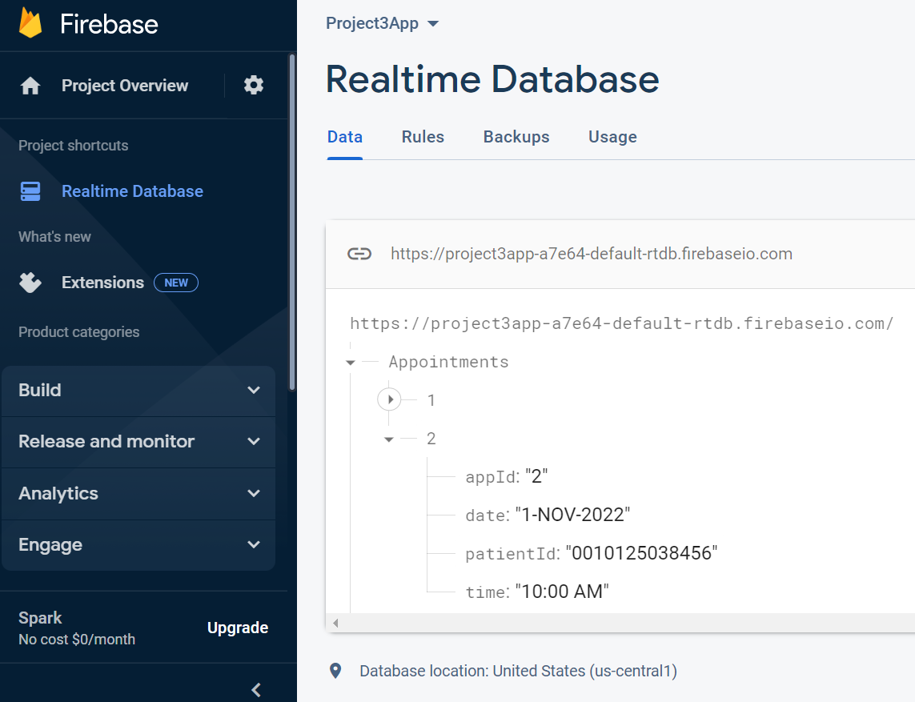
Patients appointments made

The Contact Page
The final activity contains the contact page where the patient can send us an email if they have any problems regarding the application. Medi-Station has its own email address where all queries will be sent to via the app. The first line is for the meditation email that the email will be sent to, the second line is the title so that the doctor can see what the email is about. The big block is for the message to be typed in.
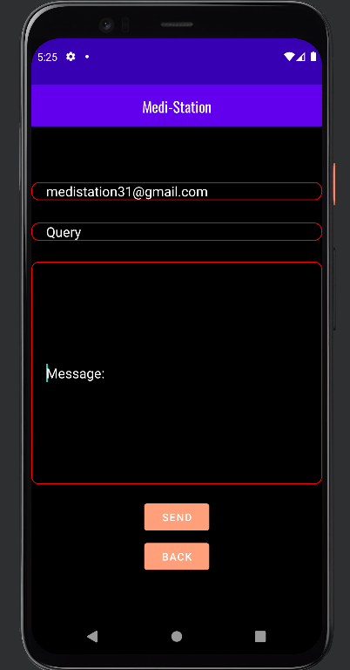
Contact Screen

CONCLUSION

Creating this app was the most fun we’ve had whole year as it was something we created from scratch. This made us proud as we learnt many things while working on this app. This app is not perfect, as there are many failures but also many successes. We as students did this to the best of our ability and I really think this is a steppingstone to future app developers. We would like to thank our lecturers as well as our supervisors for giving us this opportunity as this has definitely opened up a new world for us.

